Employability Services provided by the Employment & Skills Team

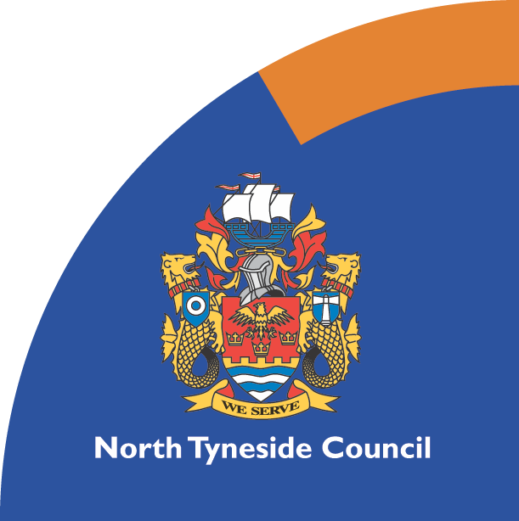





***\*These projects are part funded by the European Social Fund as part of the England 2014 to 2020 European Structural and Investment Funds Growth Programme.***

The Employment and Skills Team deliver a wide range of employability support. The team work in the local community providing confidential one to one support to help our residents move closer to work. The support includes;

* Identifying skill and strengths
* Understanding the job market
* Access to training and job opportunities
* CV’s and covering letters
* Job search websites and social media support
* Addressing barriers to employment around health, housing, debt or skills
* Support with fulfilling obligations in a claimant commitment with Jobcentre Plus
* Helping with application forms
* Maths and English provision
* Help with confidence and self esteem
* ICT support
* One to one action planning and diagnostics to identify career aspirations
* Volunteering and work experience
* General well being and social inclusion activities

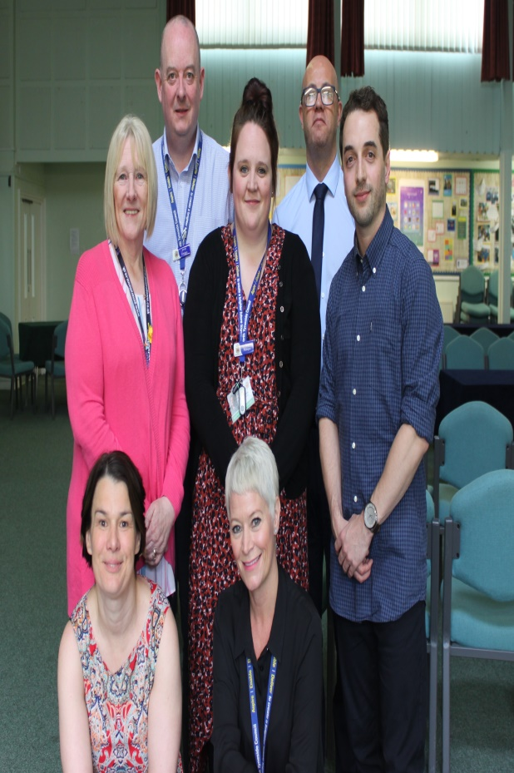

Whatever the situation, we have a project to suit an individual. Examples include;

**North of Tyne Working Homes Project**

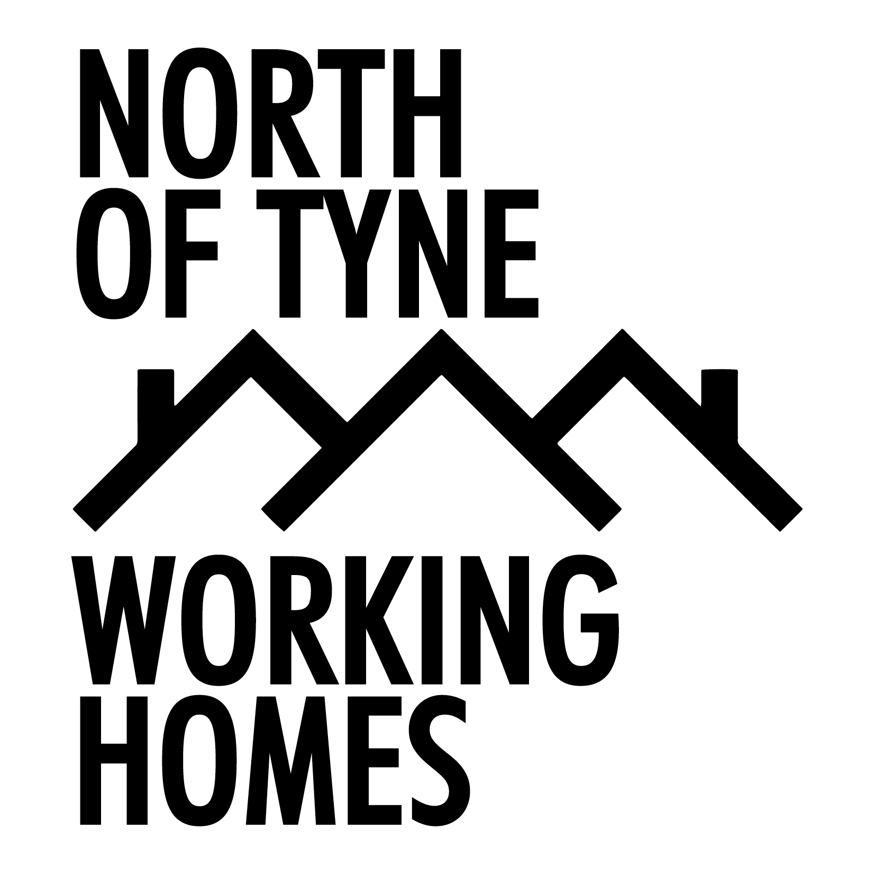

Specifically aimed at any social housing tenants.

Residents may be living in a property with North Tyneside

Homes or any other social housing such as Bernicia, Places

for People, The Guinness Trust, Karbon or any other provider

with housing stock in North Tyneside.

Our advisors will meet with residents in the most accessible venue for them and work closely with the housing teams to ensure any changes in their circumstances support stability in their homes.



**Generation NE**

Specifically aimed at young people

aged 18-29 years old.

There is a mixture of face to face and digital services that residents can access to support them move into sustainable employment. This project works across the borough in community venues and Jobcentre Plus offices. It has it’s own online jobs board and a dedicated business advisor to seek out opportunities that meet with the aspirations of those involved,



**Moving on Tyne and Wear**

Specifically aimed at residents with health barriers to

employment.

Residents have a dedicated coach who will support them to address any health concerns about moving towards employment (mental or physical). They will help them take positive steps in terms of their well being and social interactions, help them to find opportunities that suit their needs and identify supportive providers or employers.

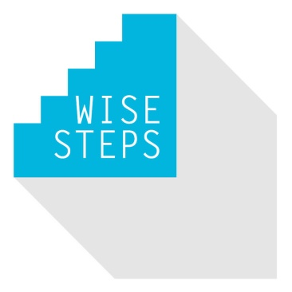

**Wise Steps**

Specifically aimed at those with multiple or complex barriers

to employment.

The project helps address any barrier preventing residents

move into work. It provides tailored one to one support to

help residents take positive steps towards work. Initial steps

may include improving their well being or social interactions

to volunteering, training and work experience.



**General employment and skills support**

Provided for those who fall outside the criteria of funded

projects who are unemployed, economically inactive or on

a low income and seeking more sustainable work.

**Recruit Silverlink**

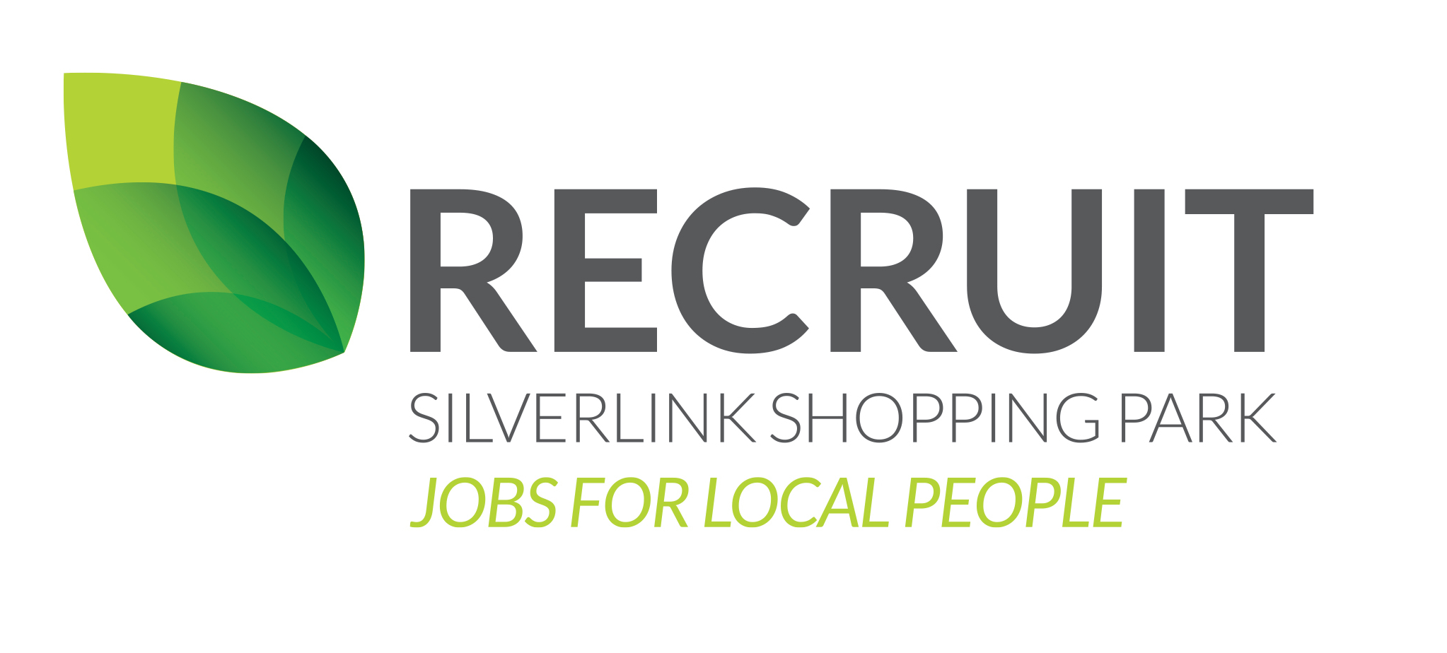

A project to connect local people to local retail jobs.

It aims to fill short and long term vacancies with trained,

local candidates who fit well within our local businesses. The project is supporting candidates throughout the process with the aim of delivering skilled, job-ready people for the available roles.

To find out more or to refer any resident you are working with;

Email: [employability.skills@northtyneside.gov.uk](mailto:employability.skills@northtyneside.gov.uk)

Telephone: 0191 643 2288 (Option 4)

Text: ‘HELP’ to 07583 153 385

Message on Facebook: @NTAdultLearning

Advisor contact details;

 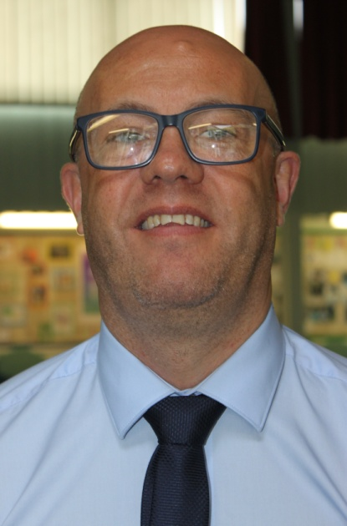 

Amy McIntyre Anthony Asiamah Chris Payne

07964 133 763 07583 680 570 07966 329 795

 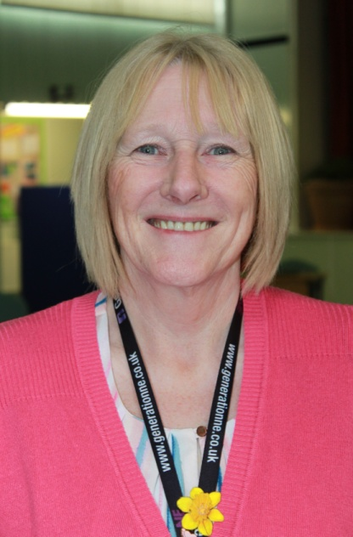 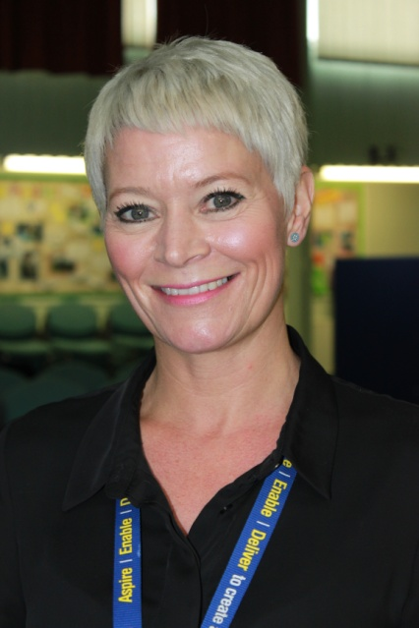

Jimmy Costigan Lorreen Butler Sharon Percy

07583 153 385 07815 784 114 07580 978 958

 

Tracey Morgan Lorna Gray Carolyn Smoult

07583 666 513 07966 874 546 07855 417 412

**An Information Day**

We are hosting an information day on Wednesday 3rd of July between 9.30am and 12.00pm.

It is an opportunity to network with our team and gain an insight into our provision. The event is open to professionals who want to find out more about the service offer and residents who would like to access the support.

Have all your questions answered. Come along and explore how we can collaborate to support local residents or bring your clients / service users so they can hear first hand about how our projects can help them.