North Shields

Men’s Club

2nd November

1-3pm

A new social group for Men aged 50+ in North Shields.

* Try new activities
* Widen your social circle
* Explore your local area and heritage

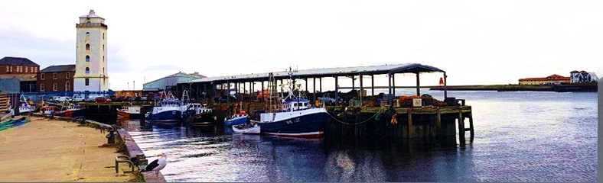

A new social group for Men aged 50+ in North Shields.

* Try new activities
* Widen your social circle
* Explore your local area and heritage



North Shields

Men’s Club

2nd November

1-3pm

The group will meet every other **Thursday** at –

Meadow Well Connected, Waterville Road, North Shields, NE29 6BA.

Refreshments will be provided.

This group has been developed in partnership with Meadow Well Connected and Age UK North Tyneside, you can contact either Meadow Well Connected or Age UK North Tyneside for more information.

**Meadow Well Connected**

Charity No. 1070839

Company No. 3433417

Telephone No. 0191 341 0033

Email: [leah@meadowwellconnected.org.uk](mailto:leah@meadowwellconnected.org.uk)

Website: [www.meadowwellconnected.org.uk](http://www.meadowwellconnected.org.uk)

**Age UK North Tyneside**

Charity No. 1049527

Company No. 1763579

Telephone No. 0191 280 8484

Email: [enquiries@ageuknorthtyneside.org.uk](mailto:enquiries@ageuknorthtyneside.org.uk)

Website: <http://www.ageuk.org.uk/northtyneside>

The group will meet every other **Thursday** at –

Meadow Well Connected, Waterville Road, North Shields, NE29 6BA.

Refreshments will be provided.

This group has been developed in partnership with Meadow Well Connected and Age UK North Tyneside, you can contact either Meadow Well Connected or Age UK North Tyneside for more information.

**Meadow Well Connected**

Charity No. 1070839

Company No. 3433417

Telephone No. 0191 341 0033

Email: [leah@meadowwellconnected.org.uk](mailto:leah@meadowwellconnected.org.uk)

Website: [www.meadowwellconnected.org.uk](http://www.meadowwellconnected.org.uk)

**Age UK North Tyneside**

Charity No. 1049527

Company No. 1763579

Telephone No. 0191 280 8484

Email: [enquiries@ageuknorthtyneside.org.uk](mailto:enquiries@ageuknorthtyneside.org.uk)

Website: <http://www.ageuk.org.uk/northtyneside>