Adult AD/HD Groups North East Support Groups North East UK
http://aadhd-ne-uk.weebly.com/

Contact: Bill Scott 07856212564 | aadhd_ne@yahoo.co.uk
Our Next Meeting in South Shields will be held on
FRIDAY 18th JUNE 2021 | 6 to 9 PM
Venue: South Tyneside Age Concern (ACTS): Dora Dixon House, 29 Beach Road / Corner of Anderson Street, South Shields NE33 2QU
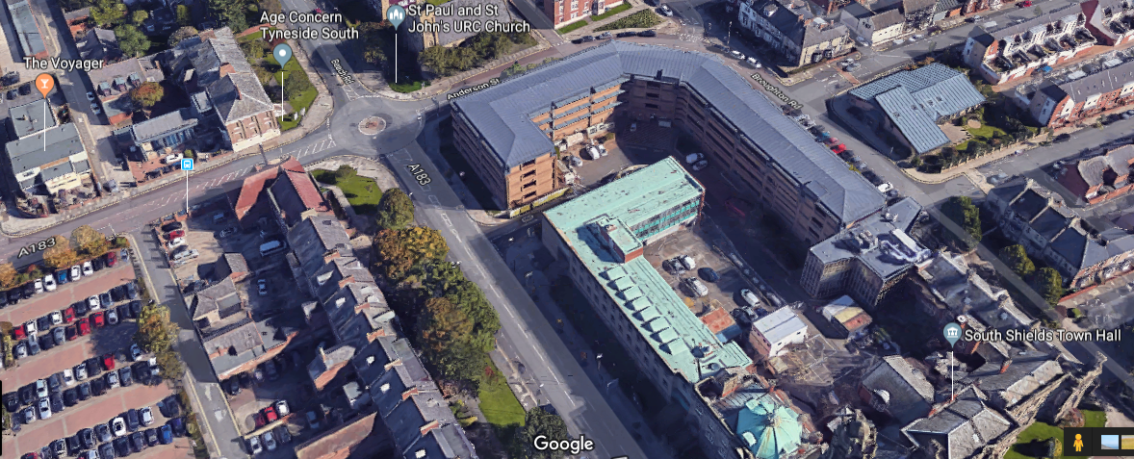
Thanks to our friends at Age Concern (ACTS) we hold regular meetings in South Shields, South Tyneside, an excellent venue, next to the small roundabout on the intersection of Beach Road and Anderson Street. There are various local car parks: opposite the side of the Town Hall on Beach Road where parking restrictions end at 6pm. There is also free parking in the back lane between Age Concern and the Voyager pub (access first left, 100 yards past ACTS further down Beach Road, heading East).
Our meetings are friendly & informal and open to anyone with a diagnosis (or in the process of seeking a diagnosis) of ADD ADHD & related conditions; parents & partners, allies, academics and professionals involved with AD/HD, or a related field, are also very welcome. Please come along and share your experiences and knowledge of AD/HD, discuss the help that is available & useful coping techniques that minimise some of the difficulties that AD/HD etc. can present. We also like to celebrate the positive aspects of living with AD/HD.
Details with regards to our other regional meetings will also be posted on our website soon.

