You’re Invited

to Join us at

Dancing for the Brain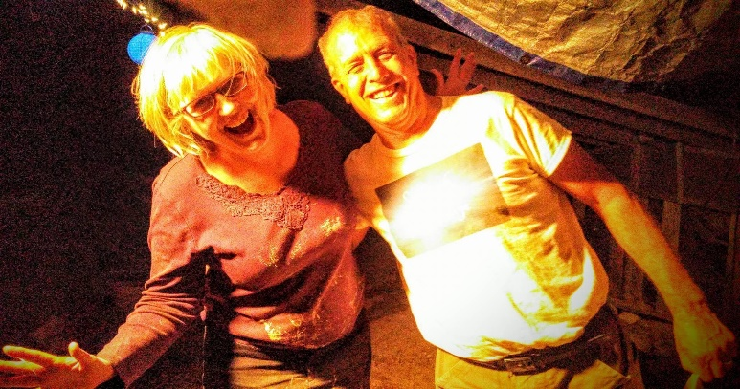

Are you supporting/caring someone who is experiencing DEMENTIA or ALZHEIMERS?
If YOU ARE then our weekly ‘DANCING for THE BRAIN’ dance is for you. Why not give us a try, come along together and spend a relaxing fun, social afternoon where you can both enjoy dancing and music that you like with people who have a similar caring role.
There will be every type of dance Disco, Northern Soul, Jive, Rock n Roll, Ballroom and Latin, Sequence Dancing, Line Dancing and fun dances to the music that will have you on the dance floor and singing along to your favourite tunes.
If getting here or transport is an issue please give us a ring and we’ll see what we can do.

EVERY Thursday STARTING ON 2 SEPTEMBER from 1 pm until 3 pm

refreshments provided
COME ALONG TO THE BALLROOM AT
Wallsend Memorial Hall and People’s Centre
Frank Street, Wallsend, NE28 6RN

For Further information contact: Lesley Spillard Tel: 07988901434

